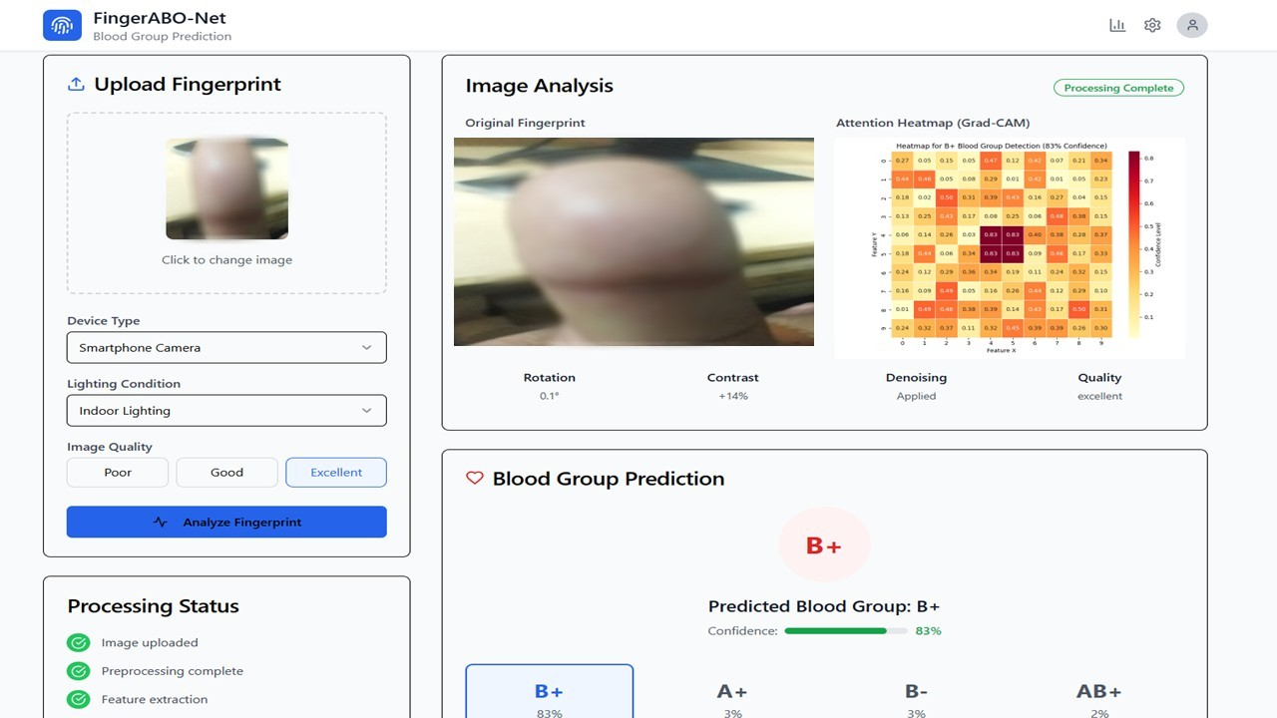

Above figure illustrates a representative pipeline input (anonymized fingerprint capture) alongside its corresponding output (Grad‐CAM overlay and blood-group prediction). In compliance with Institutional Review Board (IRB) Protocol No. 134 and to safeguard participant privacy, all raw fingerprint regions have been intentionally blurred; no identifying ridge minutiae or subject metadata are exposed.

The below Figure presents the AI-generated explanation from FingerABO-Net for a fingerprint-based blood type prediction. It displays a concise rationale written in clinical language, derived from Grad-CAM saliency, ridge pattern confidence scores, and metadata analysis. The explanation includes a confidence level (e.g., 83%) and processing time (e.g., 1576 ms), contextualizing model output for domain experts. Importantly, it’s labeled “for research purposes only,” reinforcing that this system supports interpretability and trust—but does not replace laboratory diagnostics. The structured narrative helps clinicians understand why the model arrived at its prediction, anchoring interpretability in both visual evidence and domain terms.

